EE 603

SPECTRAL ESTIMATION

TAKE HOME EXAM

e1124346
Salim SIRTKAYA

01 November 2004
TABLE of CONTENTS
General Information about the report 3
Exercise C2.17: Zero Padding Effects on Periodogram Estimators 3
Exercise C2.19: Bias and Variance Properties of the Periodogram Spectral Estimate 6
Bias Properties (a) 6
Bias Properties (b) 7
Bias Properties (c) 9
Bias Properties (d) 10
Variance Properties (a) 11
Variance Properties (b) 12
Variance Properties (c) 14
Exercise C2.20: Refined Methods: Variance-Resolution Tradeoff 16
Broadband ARMA PROCESS (a) 16
Broadband ARMA PROCESS (b) 18
Narrowband ARMA PROCESS 19

General Information about the report
In this report you can find the solutions to the exercises given in ‘INTRODUCTION to SPECTRAL ANALYSIS’ book. These exercises are:
- Exercise C2.17 :Zero Padding Effects on Periodogram Estimators
- Exercise C2.19 :Bias and Variance Properties of the Periodogram Spectral Estimator (except part e in Bias Properties)
- Exercise C2.20 :Refined Methods: Variance-Resolution Tradeoff (except part c both in Broadband and Narrowband ARMA processes)
The algorithms are implemented in .MATLAB 6.0 . The m-files of the implementations are given at the Appendix. Some commonly used Matlab functions (fft, ifft etc.) and welchse,btse functiions are used throughout the implementations. Other than these, all the implementations are written by Salim SIRTKAYA.
The spectral estimates are plotted as they are. Instead of plotting the real PSD, a dB or H(w)/H(0) plot can be chosen. But the discussions are conducted with the awareness of this fact.

Exercise C2.17: Zero Padding Effects on Periodogram Estimators
The sequence under concern is:
y[n] = 10sin(0.2*2πn+Φ₁) + 5sin((0.2+1/N) 2πn+Φ₂) + e[n]
e[n]: White Gaussian Noise with variance ; 1 Φ₁= Φ₂=0 , N=64
Spectrum of y[n] is given as:
Φ(w) = 50π[δ(w-0.2*2π) + δ(w+0.2*2 π)] + 12.5π[δ(w-(0.2+1/N)*2π) + δ(w+(0.2+1/N)*2 π)] + 1

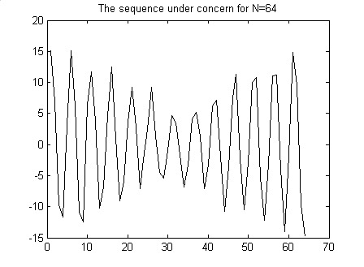
Figure 1 The original sequence of Ex 2.17
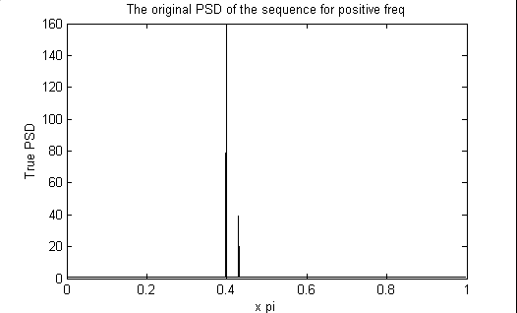
Figure 2 True power spectrum of the sequence in Ex 2.17
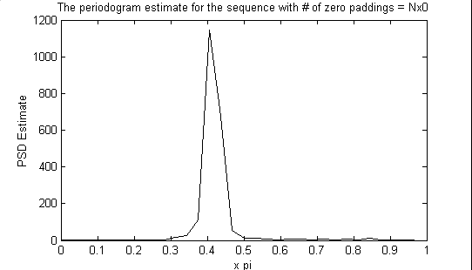
Figure 3 Periodogram PSD estimate for no zero padding
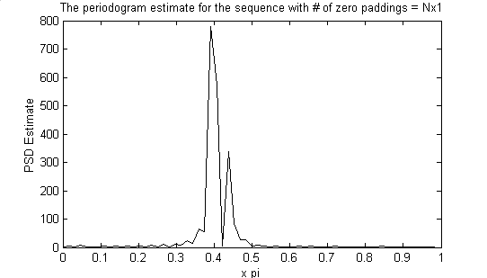
Figure 4 Periodogram PSD estimate with N zero padding
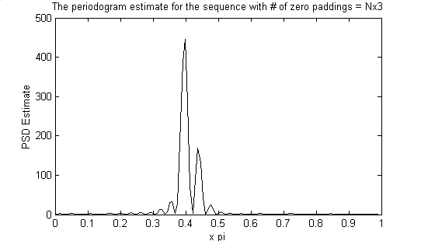
Figure 5 Periodogram PSD estimate with 3N zero padding
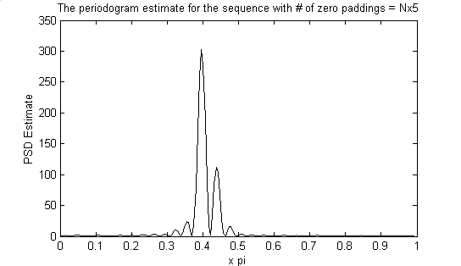
Figure 6 Periodogram PSD estimate with 5N zero padding
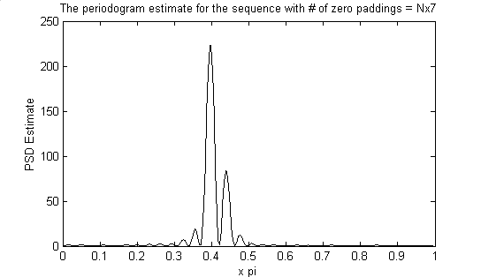
Figure 7 Periodogram PSD estimate with 7N zero padding
Comments:
- The major difference between the five spectral estimates (without zero padding, zero padding N, 3N, 5N, 7N) is the amount of power/freq. As the number of zero padding increases the power/freq decreases. This is due to the fact that, we are dividing the total power to the number of samples. Zero padding increases the number of samples but it does not affect the total power of the sequence.
- The first periodogram does not give a good description because it is estimated using 64 point fft. Therefore, the resolution of the fft process is 2pi/64=0.0982. Therefore the estimate cannot describe frequencies below 2*0.0982 (from Nyquist). However the separation between the spectral peaks of the signal is exactly 0.0982. Therefore the periodogram for N=64 cannot resolve this separation.
- It is observed that there is no significant change in the spectral resolution when the number of padded zeros increases.

Exercise C2.19: Bias and Variance Properties of the Periodogram Spectral Estimate

Bias Properties (a)
Figure 8 shows the true spectrum of the random process y[n] described in “Exercise 2.19 Bias Properties”. The true spectrum is computed by rearranging H(q) as B(q)/A(q) and then replacing q terms with e^{jw}. Then the true PSD can be computed as |B(w)/A(w) |² .
The coefficients of the filter are as follows:
a(1)=1;a(2)=1.775668;a(3)=2.672284;a(4)=1.740332;a(5)=0.960596;
b(1)=4;b(2)=7.030929;b(3)=10.473195;b(4)=6.750381;b(5)=3.687136;

The number of points used to represent the PSD is 4096.
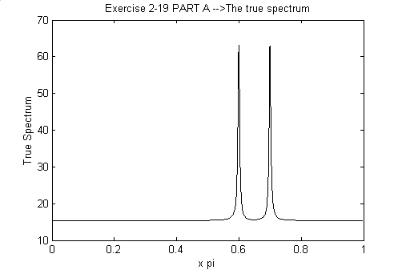
Figure 8 The true PSD of the sequence of Ex2.19 (Bias Properties)
Figure 9 shows the Autocorrelation Sequence. ACS is computed using the inverse fourier transform of the true 4096 point PSD. The autocorrelation decays rapidly as the lag increases.
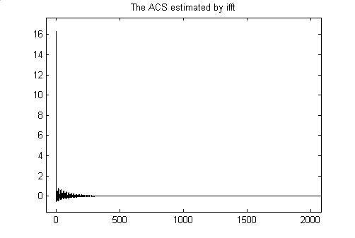
Figure 9 ACS computed by ifft of true PSD

Bias Properties (b)
Figure 10 shows 4096 point fft of the ‘Bartlett Window’ for positive frequencies. The number of window points is equal to 64.
Figure 11 shows the periodogram estimate according to equation 2.4.8 (Convolution of True PSD and Fourier Transform of Bartlett Window).
It is observed that the spectral peaks in Figure 11 is wider than the peaks in original PSD. This due to the smearing effect of the windowing process. The resolution limit of the Bartlett Window in this example is theoretically 2xpi/64 = 0.0313 x pi. The distance between the peaks of the PSD is 0.1xpi. Therefore the estimator can resolve the two peaks. However the width of the peaks is smaller than this limit. Therefore, the peaks get wider and the PSD estimate is smeared.
This wide mainlobe of the Bartlett window will decrease the resolution of the periodogram estimator.

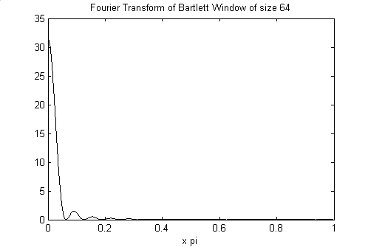
Figure 10 Fourier Transform of the Bartlett Window for positive freq. N=64
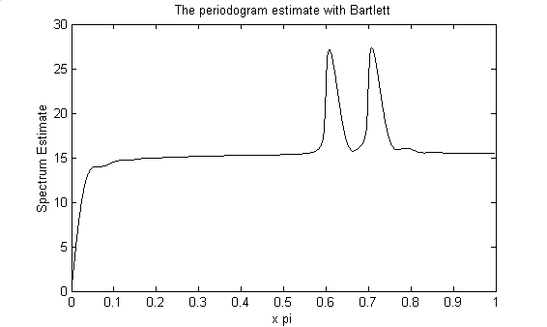
Figure 11 True PSD convolved with DTFT of Bartlett window (Equation 2.4.8)

Bias Properties (c)
Figure 12 shows the periodogram estimate for 10 realizations of the random process for N=64. Figure 13 shows the average periodogram estimate of 50 realizations. Figure 14 shows the periodogram estimate with bartlett for N=64. Figure 14 is given for comparison.
From Figure 12 it can be easily seen that the periodogram estimate has a huge variance.
By averaging the estimates the variance is decreased. We theoretically know that as the number of realizations increase the average periodogram will be more stable concerning the variance.
Comparing the average estimate to Figure 14, although the two peaks are visible we can say that the variance is still high.

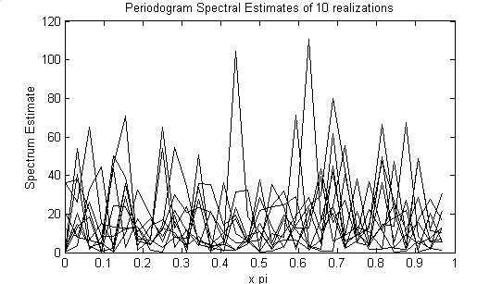
Figure 12 Periodogram Spectral Estimates for 10 realizations for N=64

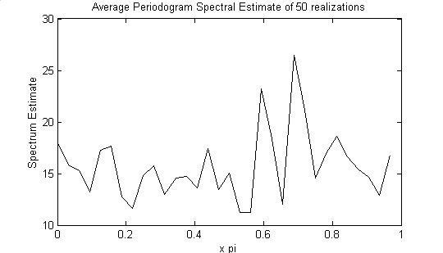
Figure 13 The average Periodogram spectral Estimate of 50 realizations for N=64
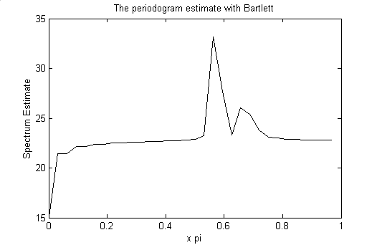
Figure 14 Periodogram Estimate in part b for N=64

Bias Properties (d)
The number of data samples is 256, therefore the bartlett window size is 256. The fft points are chosen as 256*8 to have better resolution in illustration.
Please note that in the book and in the lectures N point bartlett windows actually have 2N points because the function is two sided. For this window the resolution limit was 1/N. In MATLAB implementations when we say N point BT window it exactly has N points. Therefore for this window the resolution limit is 2/N.
When we use a BT window os size 256, the resolution limit is 2*2*pi/256=0.0156*pi radians. The seperation between the spectral peaks is 2*pi*alfa.
2*pi*alfa=0.0156*pi ==> alfa = 0.0078.
This is a theoretical value. In the implementation I take alfa as 0.008 and observed that the estimator can resolve the spectral peaks for most realizations. Instead of giving individual estimates, the average estimate of the 50 realizations is given to give a true understanding about the resolution.
shows the true PSD of the random process when alfa=0.008.
Figure 16 shows the average periodogram estimate of 50 realizations of the random process.
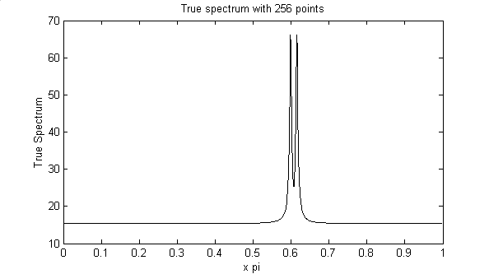
Figure 15 True Spectrum with N=256, number of fft points = N*16, alfa = 0.008
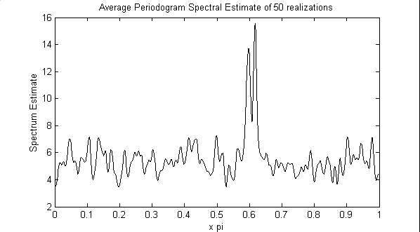
Figure 16 Average Periodogram Spectral Estimate of 50 realizations

Variance Properties (a)
Figure 17 shows the true spectrum of the random process y[n] described in “Exercise 2.19 variance properties”. The true spectrum is computed as |B(w)/A(w) |² .
The coefficients of the filter are as follows:
a(1)=1;a(2)=-1.3817;a(3)=1.5632;a(4)=-0.8843;a(5)=0.4096;
b(1)=1;b(2)=0.3544;b(3)=0.3508;b(4)=0.1736;b(5)=0.2401;
The number of points used to represent the PSD is 4096.
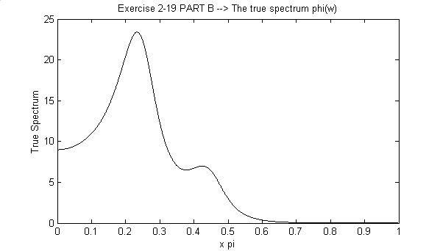
Figure 17 The true PSD of the sequence of Ex2.19 (Variance Properties)

Variance Properties (b)
Figure 18, Figure 19 and Figure 20 show the mean periodogram estimates for N=64, N=256 and N=1024. Tin the figures, the mean estimates are shown with blue line. Within each figure, the mean-std estimate is shown with green line and mean+std estimate is shown with red line. From these figures it is observed that the variance does not decrease with increasing sample number. Note that the smoothness of the first estimate is just due to the low resolution and it is just illustrative. The ±std plots give us a true understanding about the variance. Actually this is an expected results because the periodogram estimate is INCONSISTENT concerning the variance.
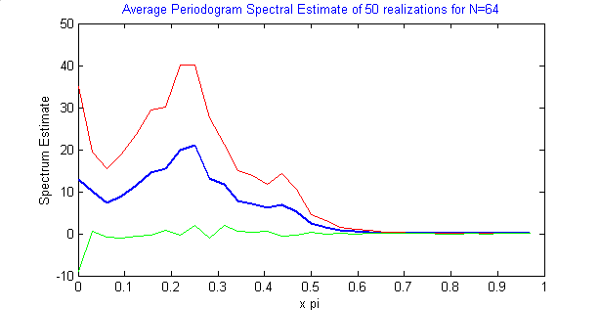
Figure 18 Blue Line : Mean Periodogram estimate for N=64
Red Line: Mean+std Periodogram estimate N=64
Green Line: Mean-std Periodogram estimate N=64
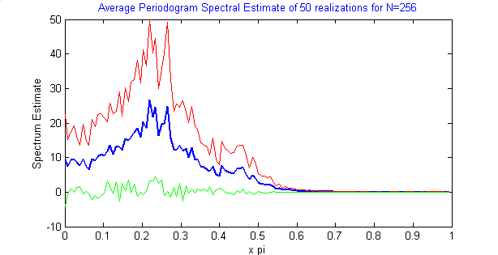
Figure 19 Blue Line : Mean Periodogram estimate for N=256
Red Line: Mean+std Periodogram estimate N=256
Green Line: Mean-std Periodogram estimate N=256
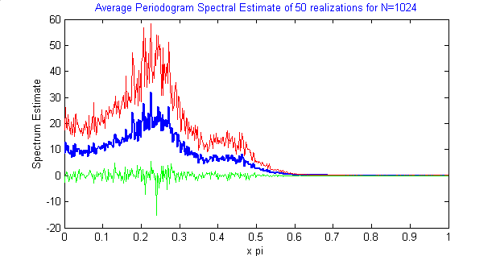
Figure 20 Blue Line : Mean Periodogram estimate for N=1024
Red Line: Mean+std Periodogram estimate N=1024
Green Line: Mean-std Periodogram estimate N=1024

Variance Properties (c)
Figure 21, Figure 22, Figure 23 show the predicted variance for N=64, N=256, N=1024 consecutively according to equation 2.4.21
(var = Φ(w)²). It is obvious that the variance does not decrease with increasing N.
Figure 24, Figure 25, Figure 26 show the ratio of standard deviation of the periodogram estimate to the true spectrum for N=64, N=256, N=1024 consecutively. These ratio curves are approximately constant within a limit. The standard deviation within the second and third ratio curves are approximately same and equals to 0.2 and their means are approximately same and equals to 1. The std for the first ratio curve is 0.9 and mean is 2.
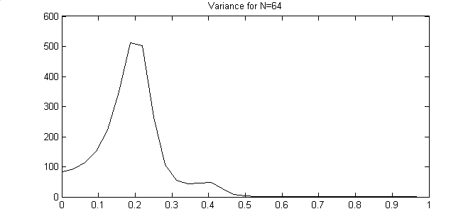
Figure 21 Predicted variance according to Equation 2.4.21 (Φ(w)²) for N=64
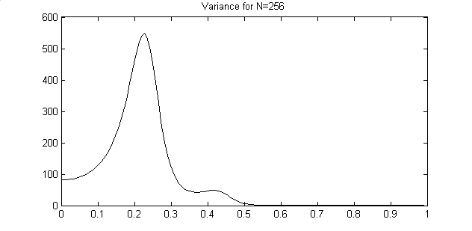
Figure 22 Predicted variance according to Equation 2.4.21 (Φ(w)²) for N=256
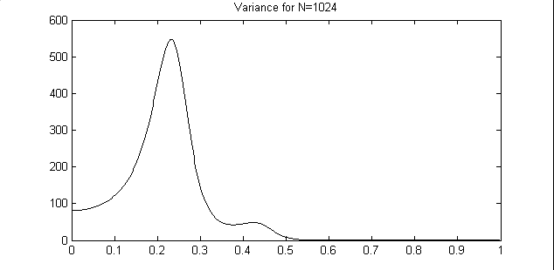
Figure 23 Predicted variance according to Equation 2.4.21 (Φ(w)²) for N=1024
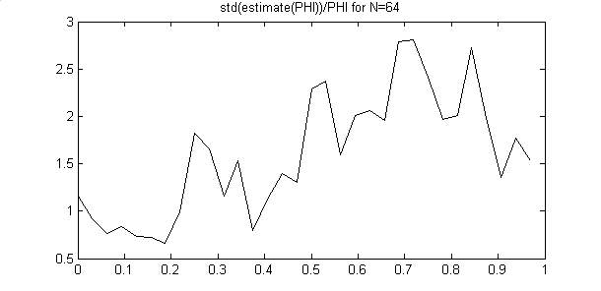
Figure 24 std(Ǿ(w))/Φ(w) for N=64
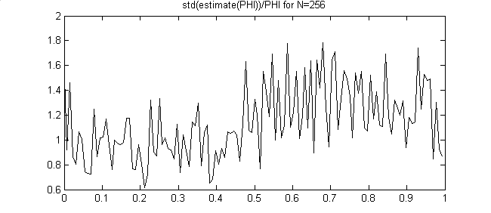
Figure 25 std(Ǿ(w))/Φ(w) for N=256
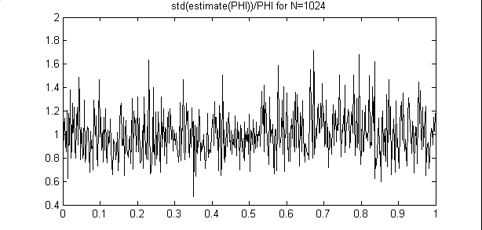
Figure 26 std(Ǿ(w))/Φ(w) for N=1024

Exercise C2.20: Refined Methods: Variance-Resolution Tradeoff

Broadband ARMA PROCESS (a)
The random process y[n] described in “Exercise 2.20 Broadband ARMA Process”.is same with the process in ‘Exercise 2.19 Variance Properties’ The true spectrum was given in Figure 17.
Figure 27 and Figure 28 show the Blackman-Tukey spectral estimates with Bartlett window of sizes N/4 and N/16 respectively (N=256 number of samples). The figures contain mean, mean+std and mean-std spectral estimates of 50 relizations in same plots.
Figure 29 and Figure 30 show the Welch spectral estimates with Rectangular window of sizes N/4 and N/16 respectively (N=256 number of samples). K is chosen as M/2. The figures contain mean, mean+std and mean-std spectral estimates of 50 relizations in same plots.
Comparison with estimates of Exercise 2.19 and with each other:
- Blackman-Tukey estimate have less variance then the periodogram estimate of exercise 2.19. This is an expected result since periodogram is an INCONSISTENT estimate. Actually the BT estimate is a locally weighted average of the periodogram estimate. By this way it smooths the periodogram estimate and avoids large fluctuations.
- In Blackman-Tukey method, since we are decreasing the number of data samples to eliminate the error in correlation for large lags, the resolution decreases. This can easily be seen from two figure of BT method. In the second figure the window size is decresed to M/16 and as a result we have a very smooth estimate.
- Welch estimate have less variance then the periodogram estimate of exercise 2.19. This is an expected result since periodogram is an INCONSISTENT estimate while Welch is not. Welch method is a modification of Bartlett method and uses overlapped data samples to increase the number of periodograms to be averaged. By this way the variance is decreased. It can be seen that the noise level increases with increasing M, but resolution gets better.
- Welch estimate have a better resolution than the Blackman-Tukey Estimate
- From the plot it is not easy to talk about the variance difference between BT and Welch. Still, BT seem to have a better characteristic.

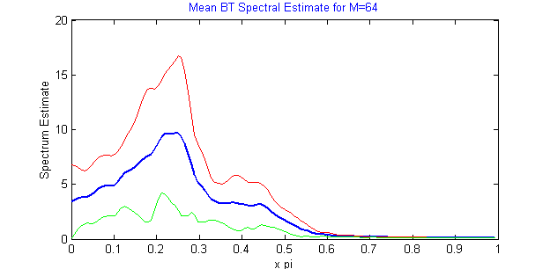
Figure 27 Blue Line : Mean Blackman-Tukey estimate for N=256, M=N/4 with Bartlett window
Red Line: Mean+std Blackman-Tukey estimate for N=256, M=N/4 with Bartlett window
Green Line: Mean-std Blackman-Tukey estimate for N=256, M=N/4 with Bartlett window
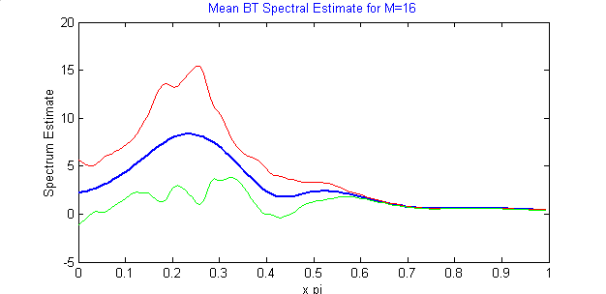
Figure 28 Blue Line : Mean Blackman-Tukey estimate for N=256, M=N/16 with Bartlett window
Red Line: Mean+std Blackman-Tukey estimate for N=256, M=N/16 with Bartlett window
Green Line: Mean-std Blackman-Tukey estimate for N=256, M=N/16 with Bartlett window
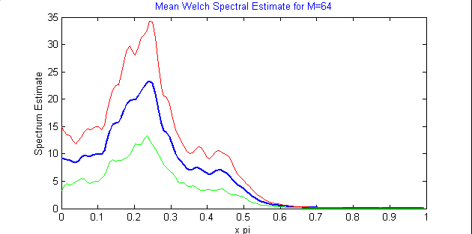
Figure 29 Blue Line : Mean Welch estimate for N=256, M=N/4, K=M/2 with Rectangular window
Red Line: Mean+std Welch estimate for N=256, M=N/4, K=M/2 with Rectangular window
Green Line: Mean-std Welch estimate for N=256, M=N/4, K=M/2 with Rectangular window
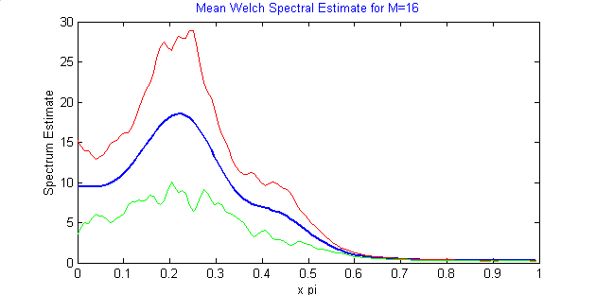
Figure 30 Blue Line : Mean Welch estimate for N=256, M=N/16, K=M/2 with Rectangular window
Red Line: Mean+std Welch estimate for N=256, M=N/16, K=M/2 with Rectangular window
Green Line: Mean-std Welch estimate for N=256, M=N/16, K=M/2 with Rectangular window

Broadband ARMA PROCESS (b)
In these refined methods the variance decrease is achieved with two different ways. BT method decreases the variance by decreasing the number of data samples. BT method is based on correlogram spectral estimate an we know that correlation is erroneous for large lags. By taking a smaller part of the correlation sequence (smaller lags) the error is eliminated. But resolution is sacrificed by this method. The resolution is decreased to 1/M. This theoretical discussion is supported by the plots given.
The Welch method splits up the data into S overlapped subgroups and estimates the windowed periodogram for each subgroup. The it averages these subgroup estimates. In this example the window is rectangular, therefore it has no effect. By using overlapping subgroups the number of subgroups is increased and a more consistent estimate is achieved. The Welch method is a CONSISTENT estimate. This theoretical discussion is supported by the plots given.

Narrowband ARMA PROCESS
Figure 8 shows the true spectrum of the random process y[n] described in “Exercise 2.20 Narrowband ARMA Process”. The true spectrum is computed as |B(w)/A(w) |² .
The coefficients of the filter are as follows:
a(1)=1;a(2)=-1.6408;a(3)=2.2044;a(4)=-1.4808;a(5)=0.8145;
b(1)=1;b(2)=1.5857;b(3)=0.9604;b(4)=0;b(5)=0;
The number of points used to represent the PSD is 4096.
Discussion:
Similar to Boadband ARMA process BT and Welch methods are conducted on this narrowband ARMA process. Since the signal is narrowband, the resolution has more importance. From the figures it can be seen that the noise level is very low and both methods have a good variance characteristic.
However, the resolution of the BT estimate is not enough to identify the peaks in the true spectrum especially for M=N/16. This is an expected result since the resolution is decreased to 1/M. The seperation between the spectral peak is approximately 0.2*pi. When M=N/4 the resolution limit is 0.0625*pi, this is an accepted limit for peak speration but the peaks get wider by this limit. However for M=N/16, thi resolution limit is 0.25*pi. This resolution cannot seperate the peaks even.
Although it has a slighly better resolution the same resolution discussion is true for Welch method.
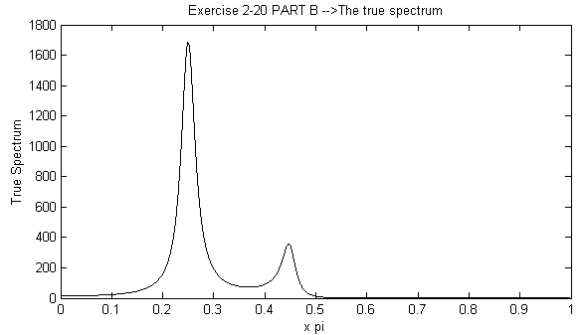
Figure 31 True PSD of the random process
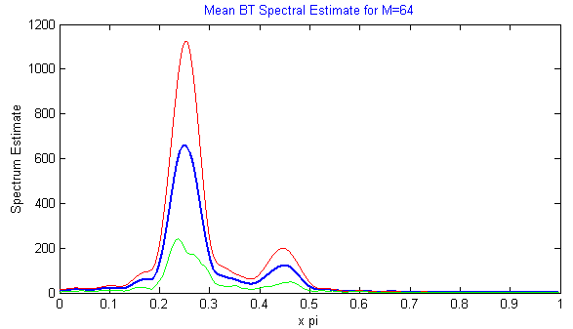
Figure 32 Blue Line : Mean Blackman-Tukey estimate for N=256, M=N/4 with Bartlett window
Red Line: Mean+std Blackman-Tukey estimate for N=256, M=N/4 with Bartlett window
Green Line: Mean-std Blackman-Tukey estimate for N=256, M=N/4 with Bartlett window
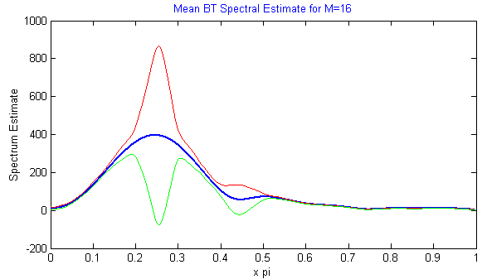
Figure 33 Blue Line : Mean Blackman-Tukey estimate for N=256, M=N/16 with Bartlett window
Red Line: Mean+std Blackman-Tukey estimate for N=256, M=N/16 with Bartlett window
Green Line: Mean-std Blackman-Tukey estimate for N=256, M=N/16 with Bartlett window
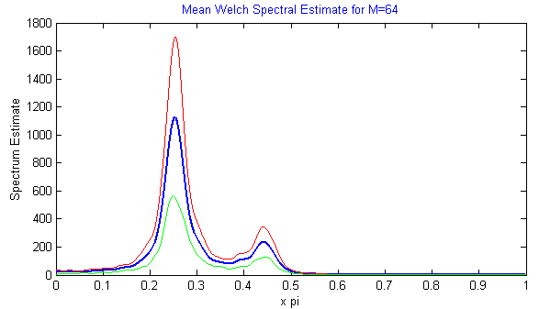
Figure 34 Blue Line : Mean Welch estimate for N=256, M=N/4, K=M/2 with Rectangular window
Red Line: Mean+std Welch estimate for N=256, M=N/4, K=M/2 with Rectangular window
Green Line: Mean-std Welch estimate for N=256, M=N/4, K=M/2 with Rectangular window
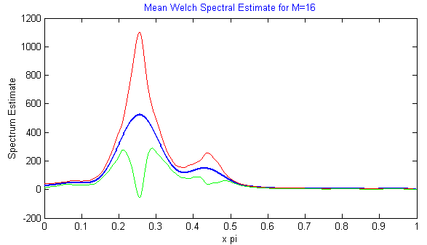
Figure 35 Blue Line : Mean Welch estimate for N=256, M=N/16, K=M/2 with Rectangular window
Red Line: Mean+std Welch estimate for N=256, M=N/16, K=M/2 with Rectangular window
Green Line: Mean-std Welch estimate for N=256, M=N/16, K=M/2 with Rectangular window

APPENDIX

M-Files

